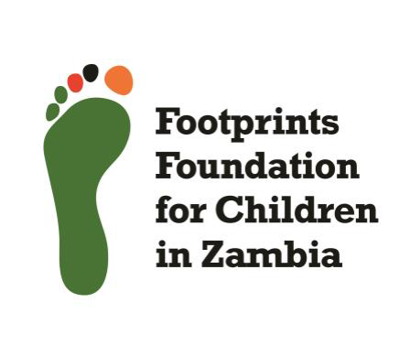

**Annual Report**

**Footprints foundation for children in Zambia**

**21st October 2023-30th October 2024**

**Table of Contents:**

1.Executive Summary

2.Introduction

3.Project Overview

4.Achievements and impact

5.Challenges faced

6.Strategies and interventions

7.Collaboration and Partnerships

8.Financial Summary

9.Future plans and Recommendations

10.Conclusion.

**1.Executive Summary**

Footprints Foundation has made remarkable strides in the past year, dedicated to transforming the lives of children on the move(street children).Our commitment to eradicating the cycle of poverty and despair has driven our initiatives, which focus on street outreach, community outreach, reintegration healthcare, Centre placement, burial support and education. This report outlines the substantial achievements we have made towards safeguarding a bright future for the vulnerable children, emphasizing the urgency of our mission and the profound impact we have made together.

A Journey of Resilience and Hope

Introduction

This story is about a young boy’s incredible strength and how support helped change his life. Despite tough times, he is becoming an inspiration for his family through his ongoing education and determination. 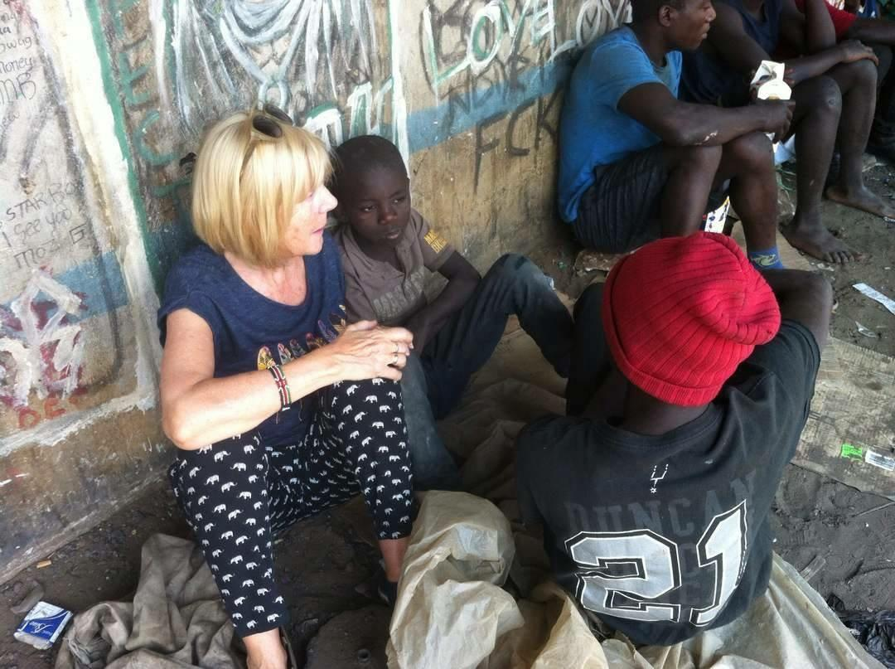

Facing Challenges

The boy’s journey began with numerous adversities. His schooling at Mthunzi,however,came to an abrupt halt due to a misundersyanding,furthermore,his family was battling severe difficulties: his mother struggled with mental health issues, while his father worked tirelessly as a security guard, earning only K900a month to support their family of nine children. This meager income was insufficient to meet even their basic needs, and the responsibility of providing for his siblings thrust adult responsibilities upon him at a painfully young age. Despite these daunting circumstances, the boy’s endurance and resilience began to emerge as he navigated the challenges of his early life.

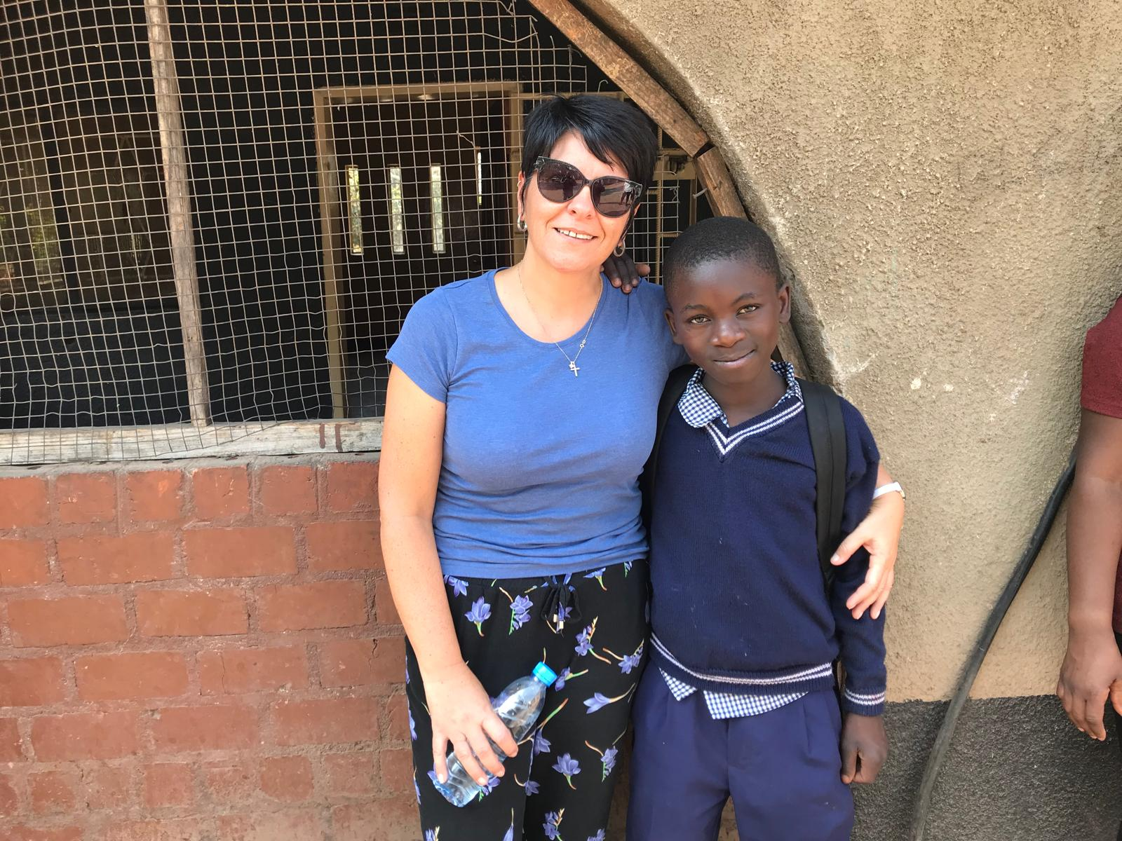

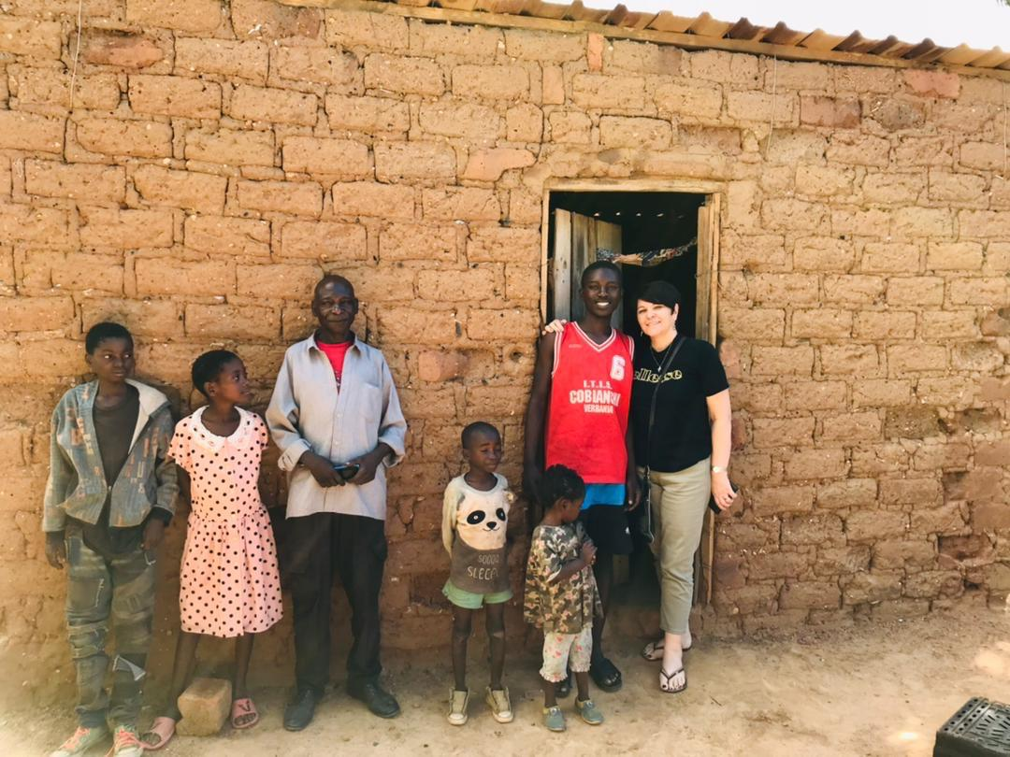

Before Things Changed

Living in a tiny two-room house, the family struggled every day. They often lacked basic necessities, with meals consisting mostly of stapes and sleeping on cold, hard floors. Because of these hardships, the boy had to make the tough decision to leave the facility, which is a choice many children in such situations have to make. After going home for a holiday and witnessing the struggles his family faced, it became even clearer how much they needed support. 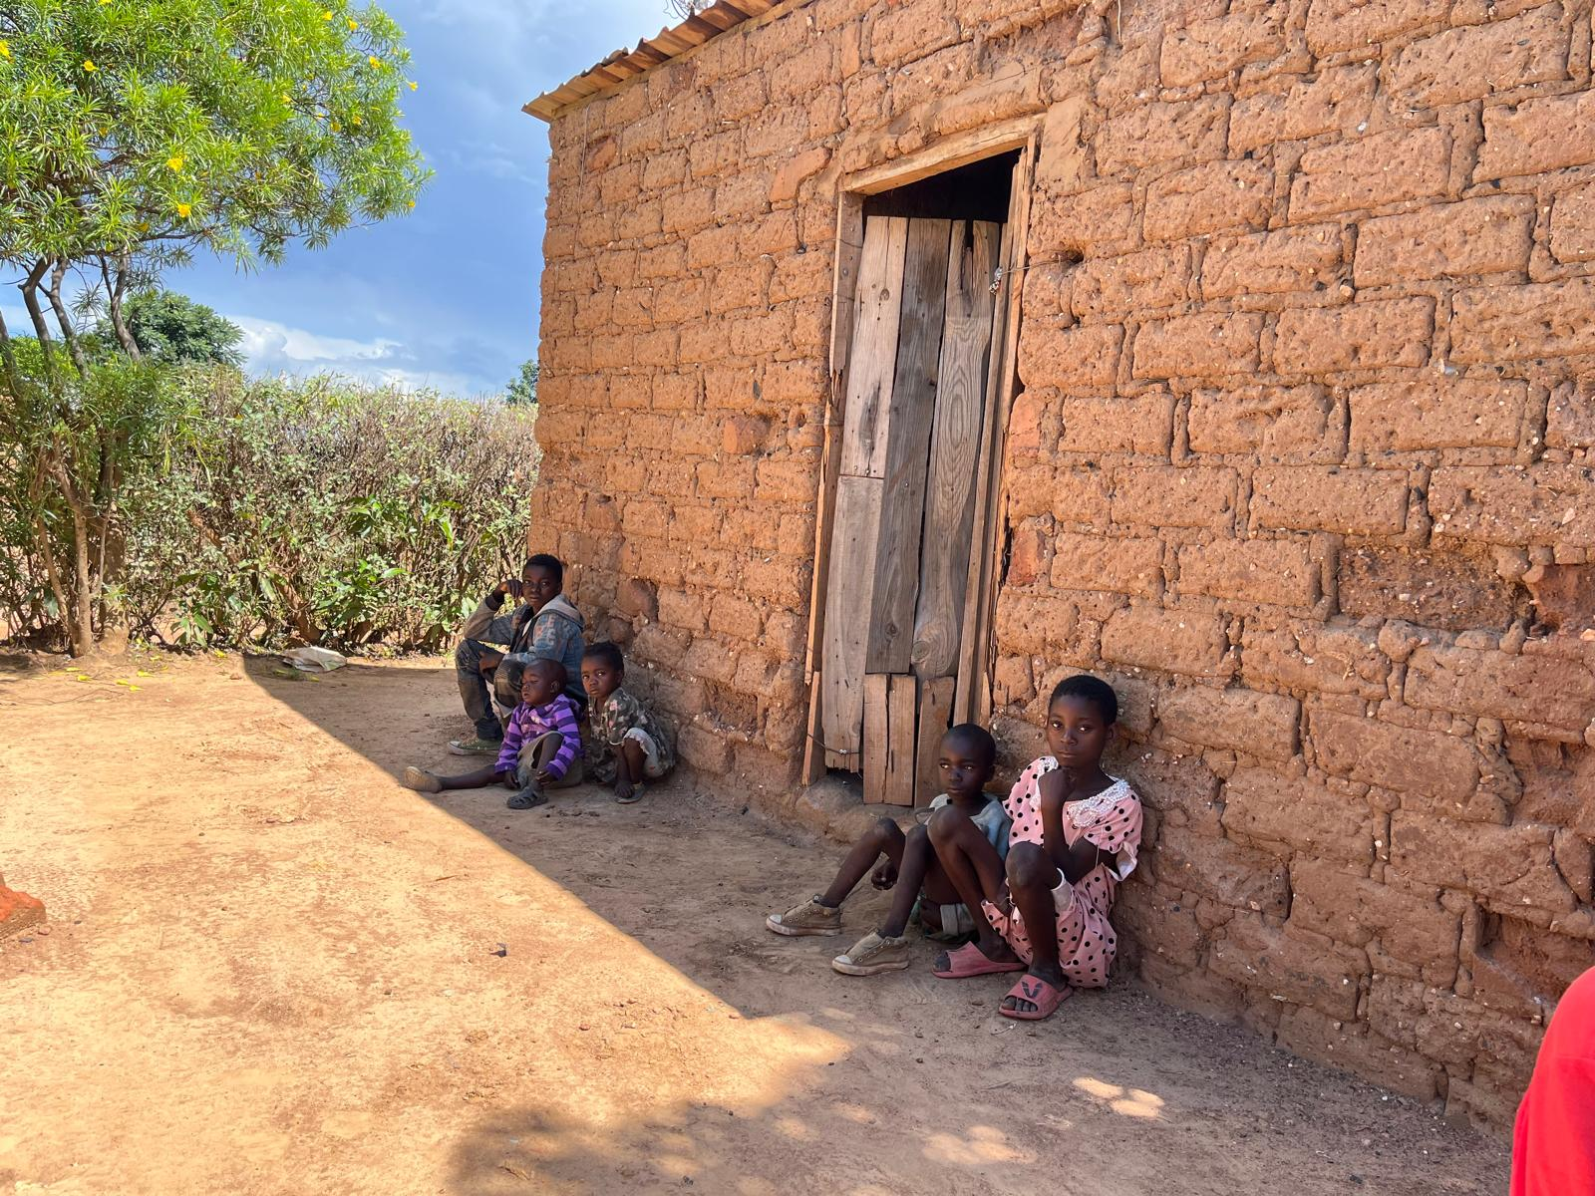

Finding Hope

Hope emerged when one of our trustees noticed the boy during a Street outreach event. The Footprints team visited his home to assess his living situation and facilitate his reintegration.However,upon arrival, they discovered that the conditions at home were not adequate for a safe and supportive environment. Recognizing the urgent need for a better setting, the team decided to place the boy at Mthunzi, where he could learn and thrive in a safe space. Their education gave him hope, and he began to thrive. Even during school breaks, he showed great dedication to his family by working to support them.However,for real change to happen, his entire family needed help.

Empowering Through Business

Understanding that lasting change was needed, his father was provided with business training and support through the help of our trustees. This helped start a business that eased their financial struggles, improved their living conditions, and gave hope to his siblings, paving the way for a better future. 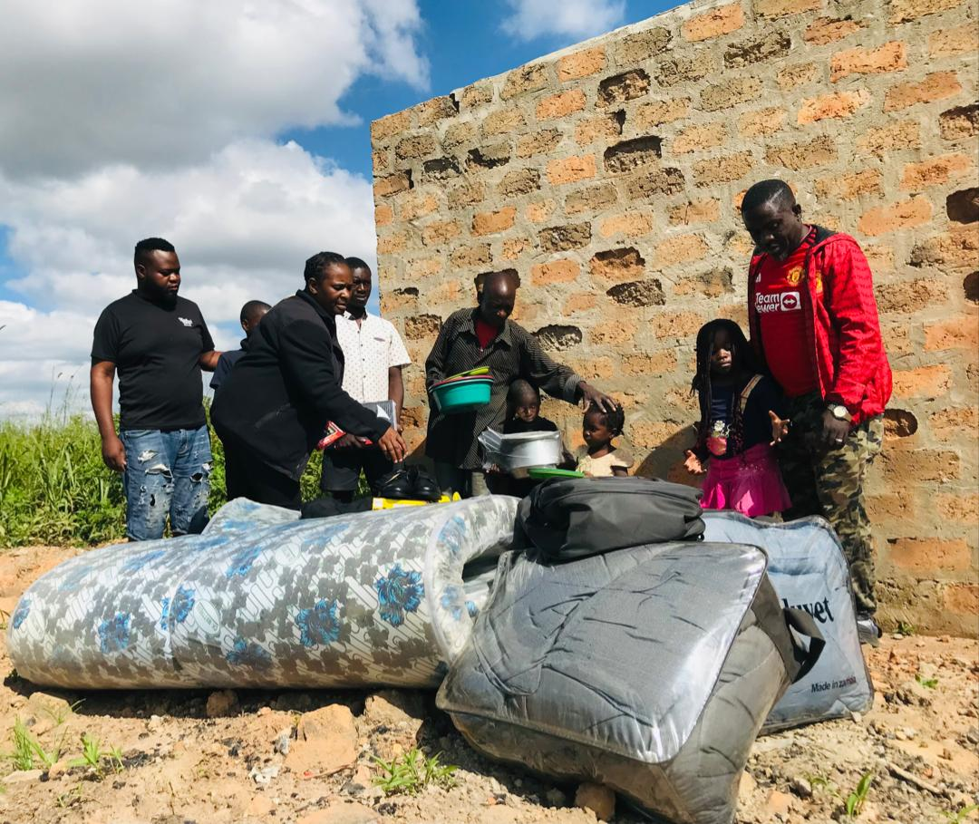

Returning to School

With financial worries reduced, he was able to return to school and continue his education with new enthusiasm. Our trustees played a crucial role in this journey by providing the necessary school requirements, including shoes, uniforms, a school bag,books,and other supplies. Now in 9th grade, he is not only succeeding as a student but also helping change his family’s situation for the better. His siblings now have the opportunity to focus on their own futures too. 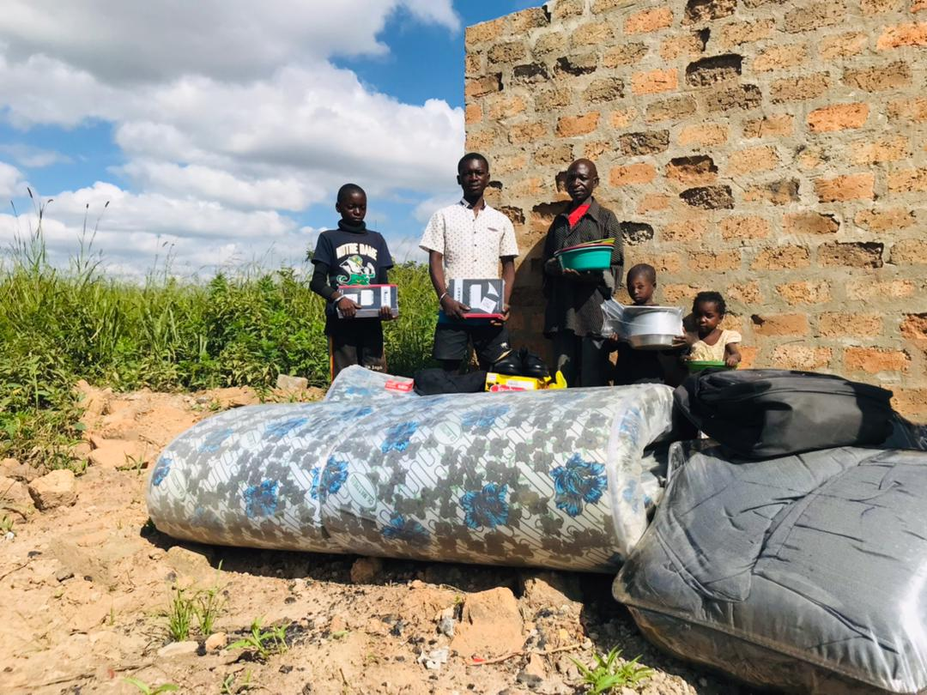

A Future Full of Hope

This boy’s story demonstrates how strong the human spirit can be and how important it is to support each other. His journey, celebrated in our report, shows our dedication to helping families like his create better futures. 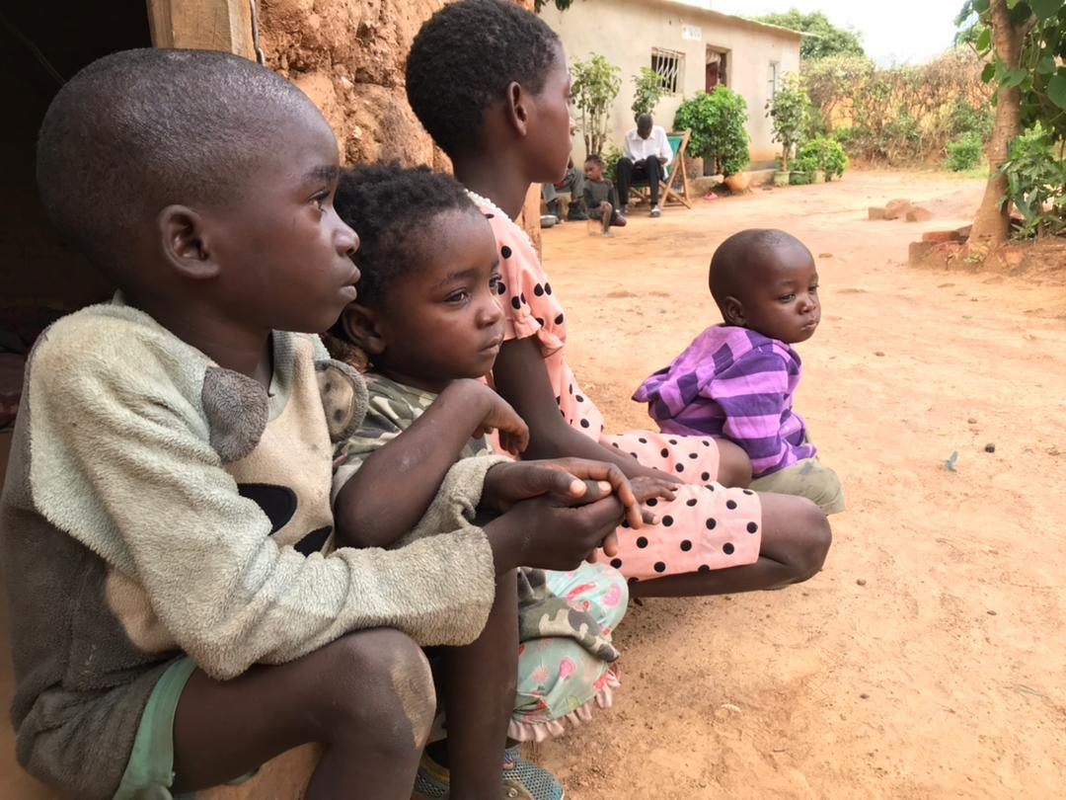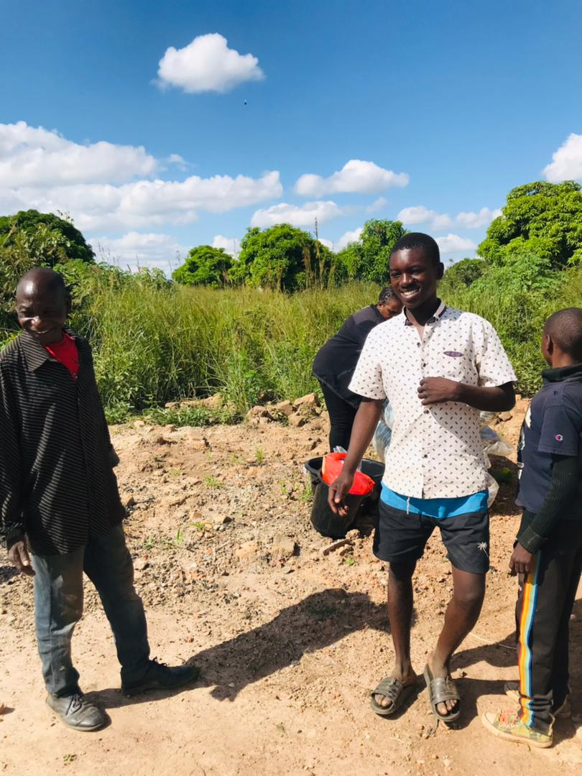

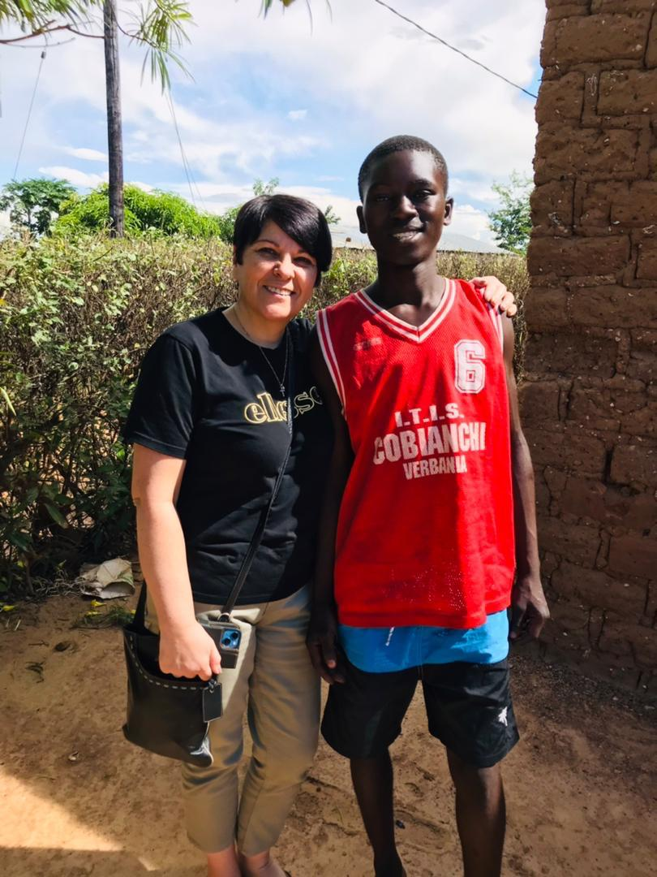

Through education, entrepreneurship, and community support, they’ve moved from struggle to hope. This story reminds us that with kindness and support, real change is possible.

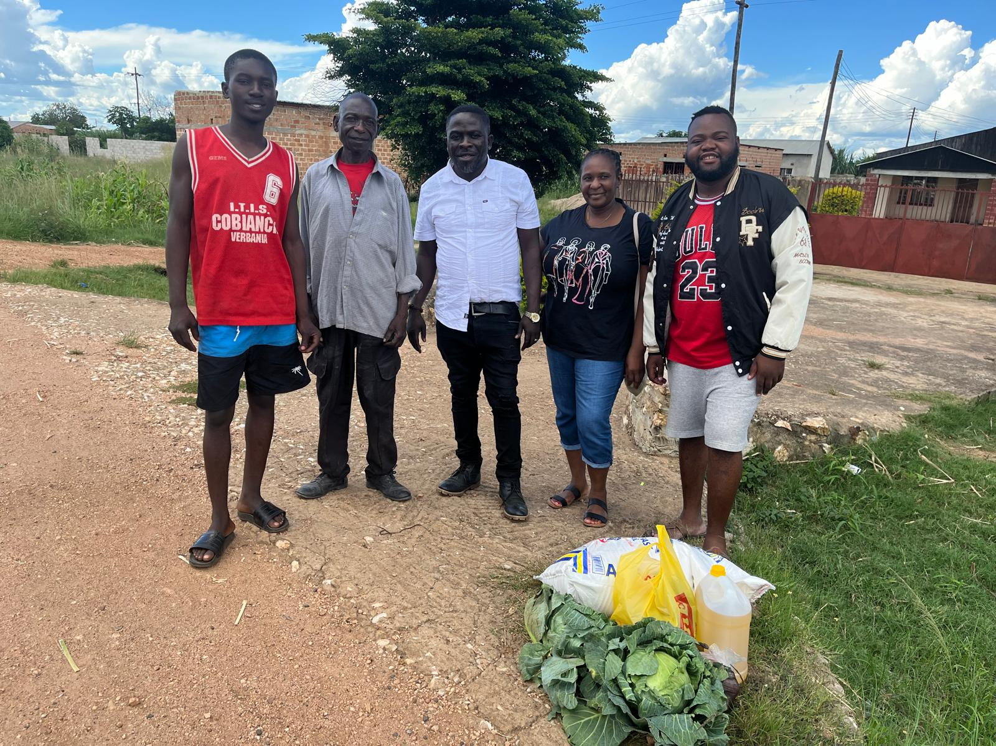

Note: The boy’s name has been withheld to respect his privacy.

We are pleased to present Footprints ‘Annual Report for 2023/2024, showcasing our ongoing commitment to transforming the lives of children on the move. Over the past year, we have made significant strides in addressing the needs and challenges faced by these children through targeted interventions and innovative strategies. 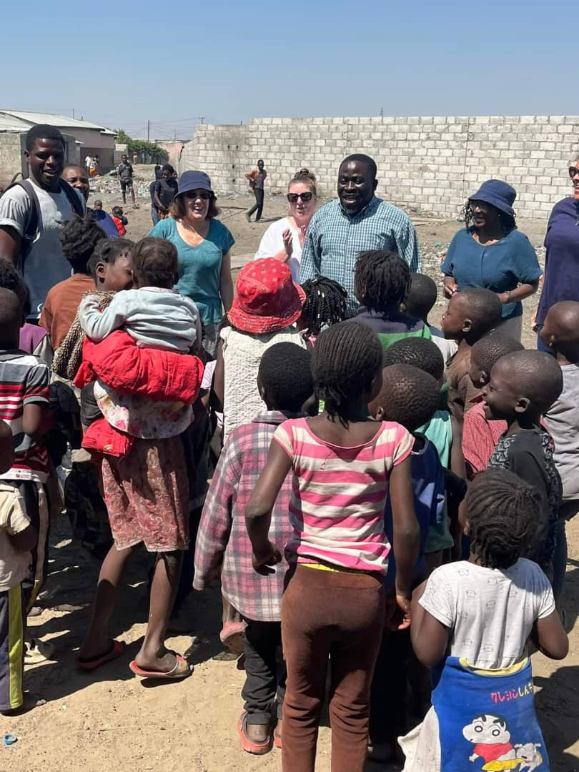

**2.Introduction:**

In every city, there is a hidden problem: children on the move(children living on the streets).These children face many hardships and do not have the safety and support that most of us enjoy. They are not just numbers; they are young lives full of hopes and dreams.

At Footprints Foundation, we believe every child deserves a chance to succeed. Over the past year, we have worked hard to help vulnerable children. We have created programs to meet their basic needs and provide them with skills and opportunities for a bright future.

This report shares the story of our work together over the past year. It highlights the challenges we faced, the successes we achieved, and most importantly, the lives we have changed. As we look back at what we have done. We also see the work that still needs to be done. Let us join together to make sure every child has the chance to grow and thrive.

**3.Project Overview:**

Footprints foundation for children in Zambia is dedicated to transforming the lives of street children through a comprehensive and compassionate approach that addresses their immediate needs and fosters long-term sustainable development. Our multi-faceted programs focus on key areas: street outreach, community outreach,reintegration,centre placement,healthcare,burial support, and education through community schools.

Street Outreach: Our street outreach initiatives are designed to create trust and rapport with street children, enabling us to assess their individual circumstances and needs. Through regular visits and engagements, our outreach team provide immediate assistance, including sanitary pads,clothing,and safety resources, as well as connecting children to supportive services.

Community Outreach: Understanding that sustainable change requires community involvement, we work closely with local families, community leaders, and organizations to raise awareness about the challenges faced by street children(Children on the move)Our community outreach programs aim to foster a supportive environment, encouraging collective responsibility and collaboration to protect vulnerable children.

Reintegration: Reintegration is critical to preventing children from returning to the streets. We provide tailored support to help children re-establish connections with their families and communities. This includes counselling,mediation,and practical assistance to address any barriers to a stable home life, ensuring a safe and supportive environment for their development.

Healthcare: Our commitment to healthcare is vital for the well-being of children living on the streets. We take these vulnerable young lives to hospitals, ensuring they receive the medical attention they desperately need. We don’t just stop at treatment; we also provide essential medications and guidance for those living with HIV, by supporting their adherence to prescribed treatments, we empower these children to reclaim their health and their futures.Together,we are not just treating illnesses-we are nurturing hope and fostering resilience in the hearts of those who need it most.

Burial Support: In the unfortunate event of a child’s death, we provide dignified burial support to families, ensuring that they can honor their loved ones without the burden of financial constraints. This service is part of our commitment to compassionately support families of street children during their most challenging times.

Education Through Community Schools: Education through community schools is a transformative initiative that empowers vulnerable children in the Misisi compound. By engaging these young minds in meaningful activities, we provide a safe haven that keeps them off the streets and fosters their potential. Through learning and community support, we are building brighter futures for these children, enabling them to rise above their circumstances and becomes catalysts for change in their own lives and beyond.

**4.Achievements and Impact**

Throughout the year, we achieved several milestones that reflect our commitment to transforming the lives of the children on the move(street children):

* Outreach Engagements:

In our commitment to uplift the children on the move(street children),We conducted 80 outreach sessions during the 2023-2024 period, directly engaging with the children on the move(street children)and assessing their unique needs. These sessions allowed us to connect on a personal level with the children on the move, providing vital support and resources to those who need it most.

During these interactions, our dedicated team not only offered immediate assistance, such as cleaning wounds and providing first aid, but also took the time to listen to the stories of each child, understanding their challenges and aspirations. We reached a total of 1000+ children, each with their own journey marked by resilience and hope. By addressing their physical and emotional needs through compassionate care, we aim to foster a sense of safety and belonging, demonstrating that they are not alone in their struggles.

* Engagement and Attendance

Our street outreach program focused on providing children on the move (street children) with a supportive environment through shared meals and community integration within the Anglican church. Mothers’ union from the Anglican church and the team successfully invited 50 street children to join them for lunch, creating an inclusive atmosphere that encouraged continued participation. Remarkably,25 of these children (50%) has since integrated into the Anglican church services, illustrating the program’s effectiveness in fostering a sense of belonging and community among vulnerable children. 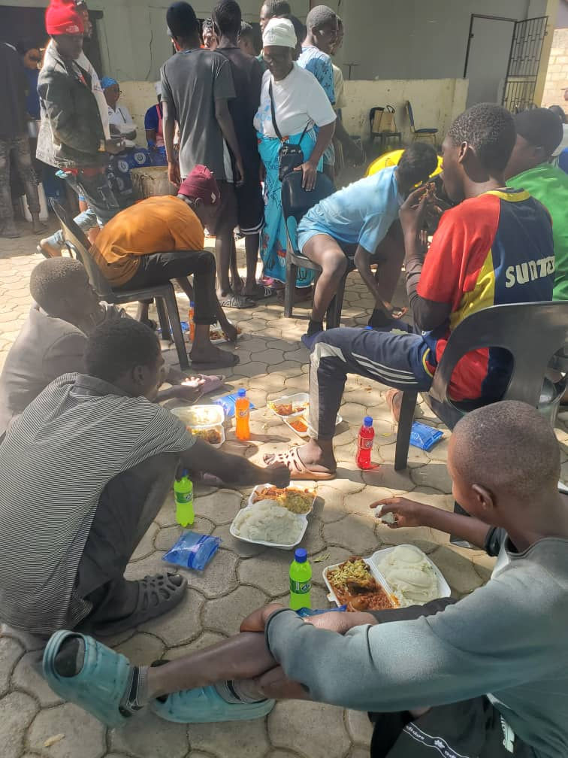

* Empowerment Through Skills Development

Our commitment to personal growth led to 10 children(20%)participating in skills development programs, equipping them with essential life skills. These programs have significantly enhanced their confidence and self-reliance, empowering them to pursue brighter futures.

* Reintegration and Support

Throughout the year, we successfully reintegrated 27 children back into their families, providing them with the support necessary to transition into stable home environments. Our team also focused on the critical health needs of vulnerable youth. We assisted nine children who were seriously ill, including a boy who was HIV positive and had previously stopped his antiretroviral therapy. Our intervention ensured he received the necessary medical attention at the University Teaching Hospital, addressing his health needs and facilitating his ongoing treatment. 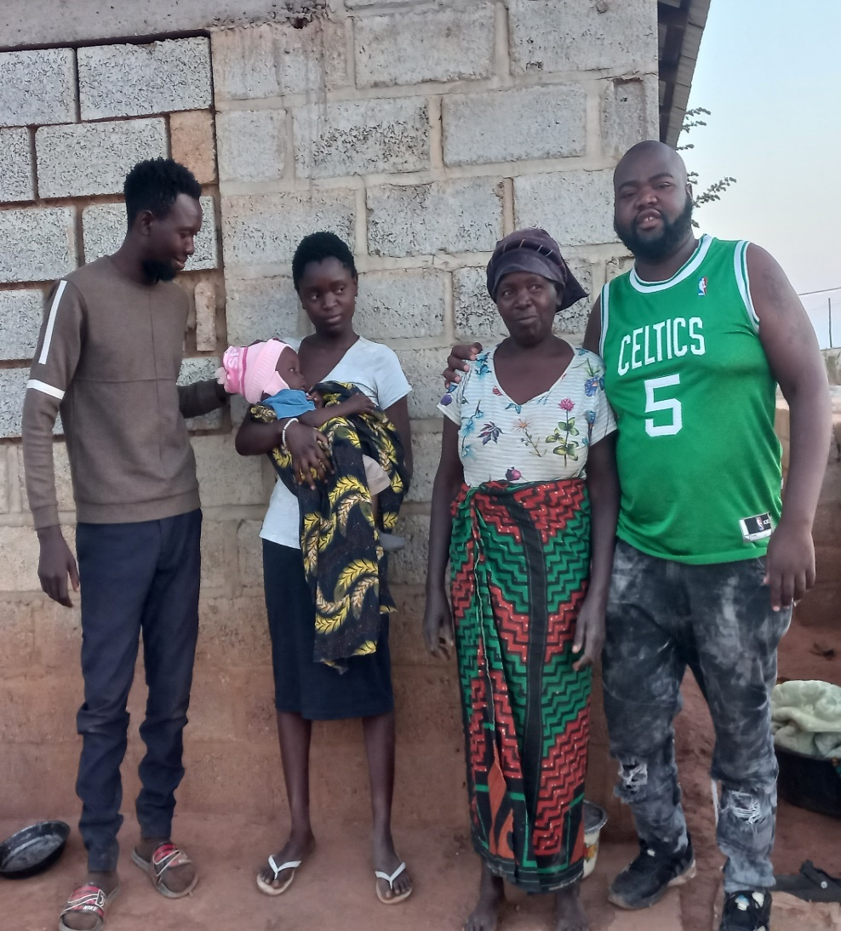

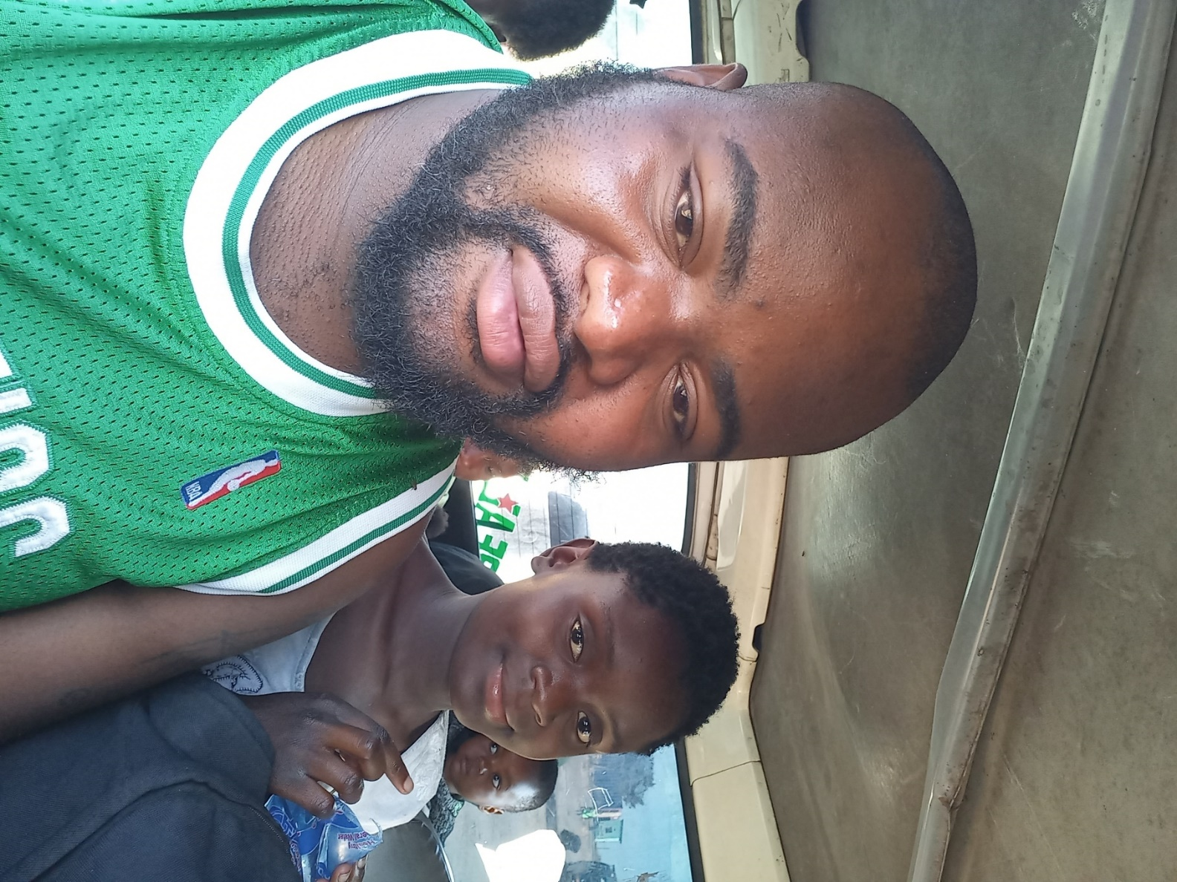

We have successfully empowered 3 families by transforming challenges into opportunities. During reintetegration,some home visits revealed environments that were not conducive to supportive family structure, in response, we implemented initiatives that equipped these families to establish small businesses, enabling them to generate income and foster a nurturing home atmosphere. This innovation not only provided financial stability but also allowed parents to be present and engaged with their children, reinforcing the family bond and ensuring a brighter future for the next generation. By turning adversity into empowerment, we have made a lasting impact on these families, cultivating resilience and hope within their communities.

* Rapid Response and Medical Assistance

Our team acted quickly in response to a tragic incident involving a 14-year-old street child who fell victim to a hit and run accident near Soweto Market. Thanks to the prompt actions of our team, he received immediate medical care, including essential procedures like x-rays and CT scans, and was referred for further assessment at the eye hospital.

* Empowering Individuals and Families

In September, a significant milestone was achieved through our mission-driven home visit to a former street young mother,Jane,who expressed a desire to start a business while expecting her third child. We provided her with a business loan, empowering her to take the first steps towards financial independence. This initiative reflected our ongoing efforts to not just provide immediate assistance but to offer sustainable solutions that uplift entire families.

* Community Engagement and Initiatives

This year, our team, Vasco and Aggie, participated in a workshop organized by plan international, in collaboration with the Child Affairs Department, focusing on safeguarding policy and the role of civil society in child protection. This training further equipped our team with the knowledge needed to enhance our protective measures for vulnerable children.Additionally,Moses attended a workshop organized by Generation Alive, aimed at empowering youth and fostering community involvement, assisting him in developing the skills required to effect positive change.

* A Heartfelt Loss

On a sad note, we mourned the tragic loss of one of the boys in our program, who was struck by a speeding vehicle in a hit and run incident. This loss serves as a poignant reminder of the challenges faced by children living in vulnerable situations.

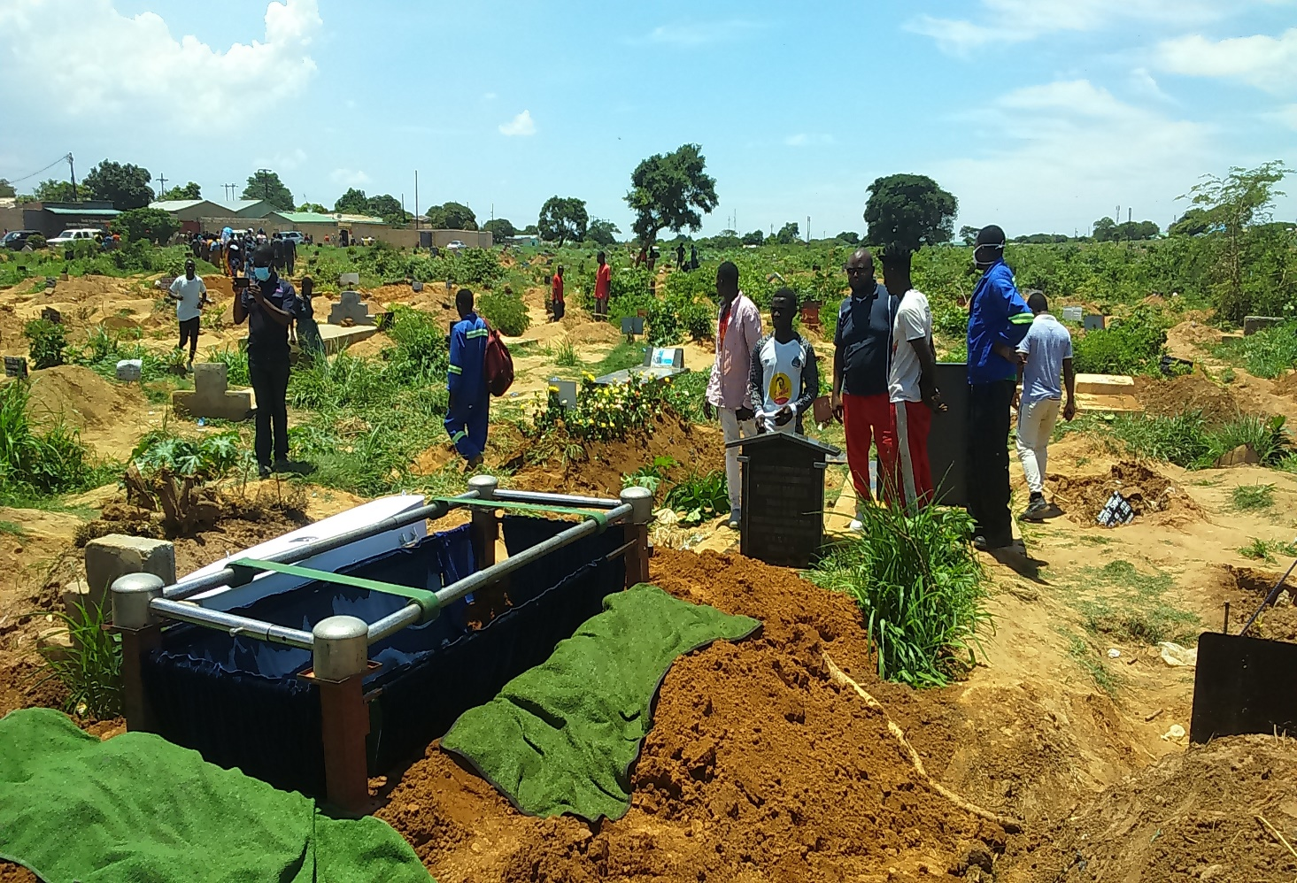

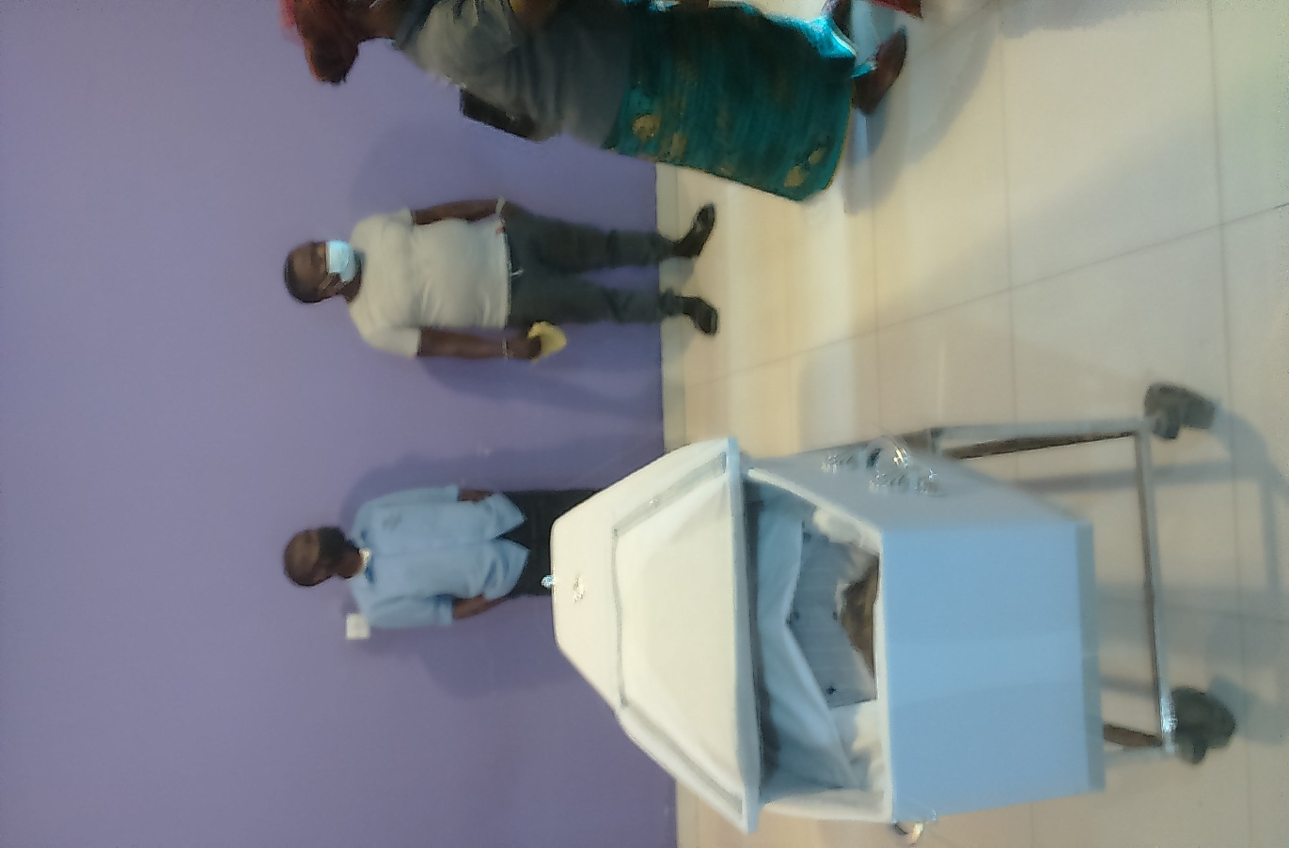

* Trustee Visits Overview

First Visit: March 14th -March 21st

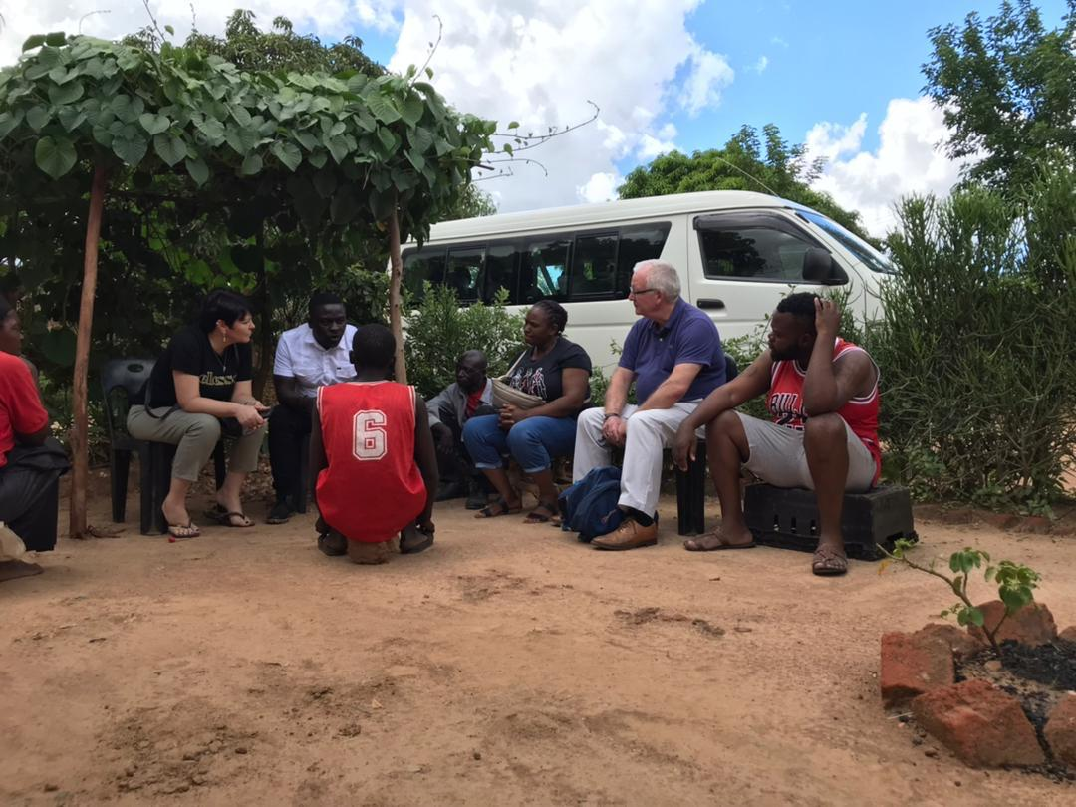

In March, we welcomed trustees to Zambia for a transformative visit that highlighted the adversity faced by street children. This visit included a significant moment where a boy from the streets was reunited with his son at Kasisi Orphanage during the visit. This encounter exemplified our holistic approach to family engagement and support, reflecting our commitment to fostering strong family connections even under challenging circumstances.

Second Visit: August-September

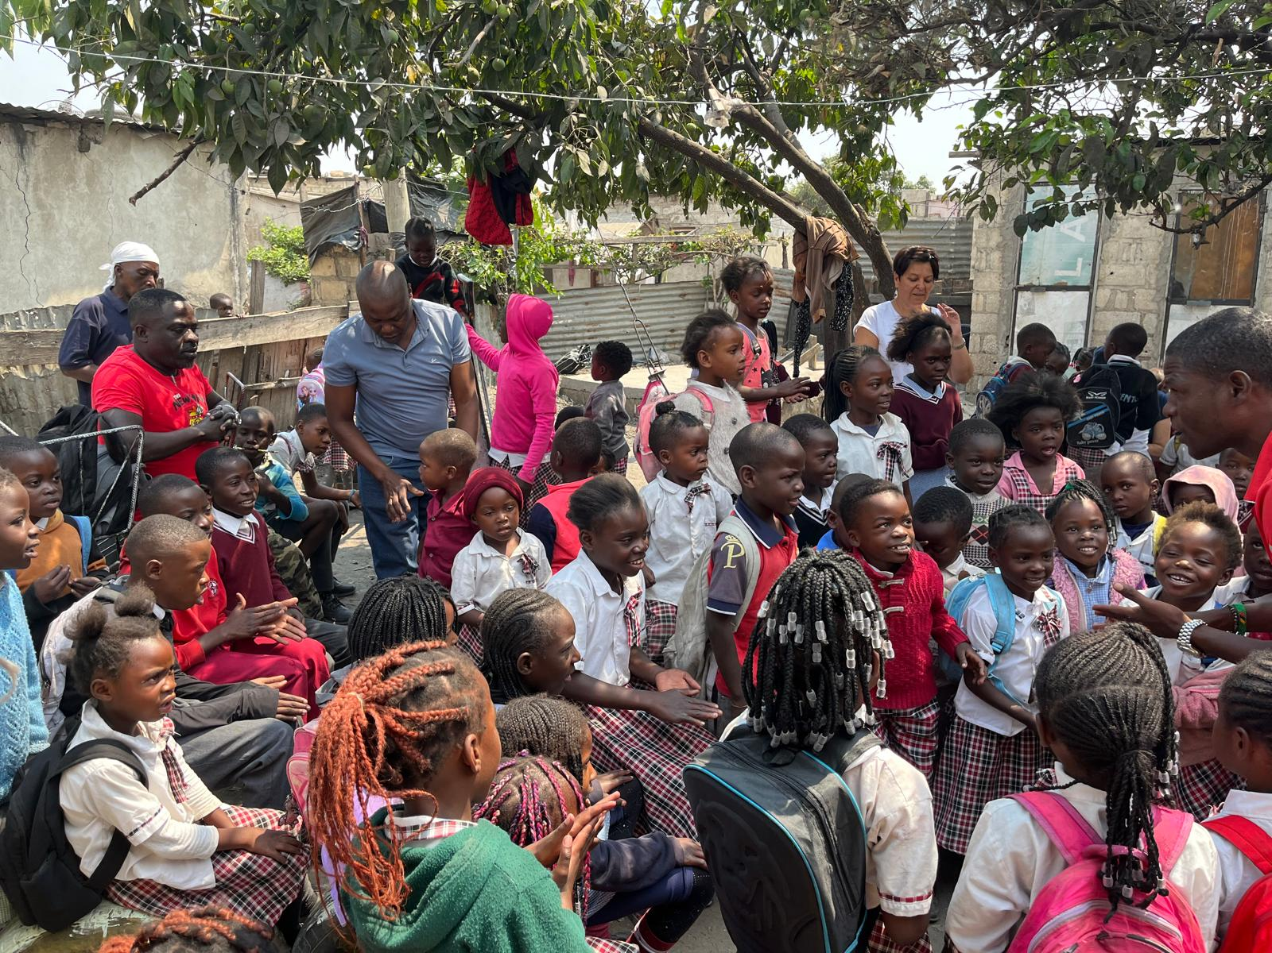

In August -September, trustees returned to Zambia as team leaders for the Mission Direct/Footprints September program. This visit focused on advancing our mission of support and engagement specifically for children on the move(street children).Our trustees played an essential role in guiding initiatives aimed at empowering the vulnerable children. Their leadership involvement reinforced our dedication to enriching the lives of children on the move(street children)through practical support and engagement.

Annual Cycle Ride Event for 2024

On September 15,2024,Roger embarked on our annual cycle fundraising event, dedicated to providing transitional housing for Zambian children. This marked his third year of participating in the event, having started this journey in 2022.In his first year, Roger cycled from Cosmopolitan Mall to Zimbabwe, and in 2023,he rode from Cosmopolitan Mall to Kazungula,Bostwana.

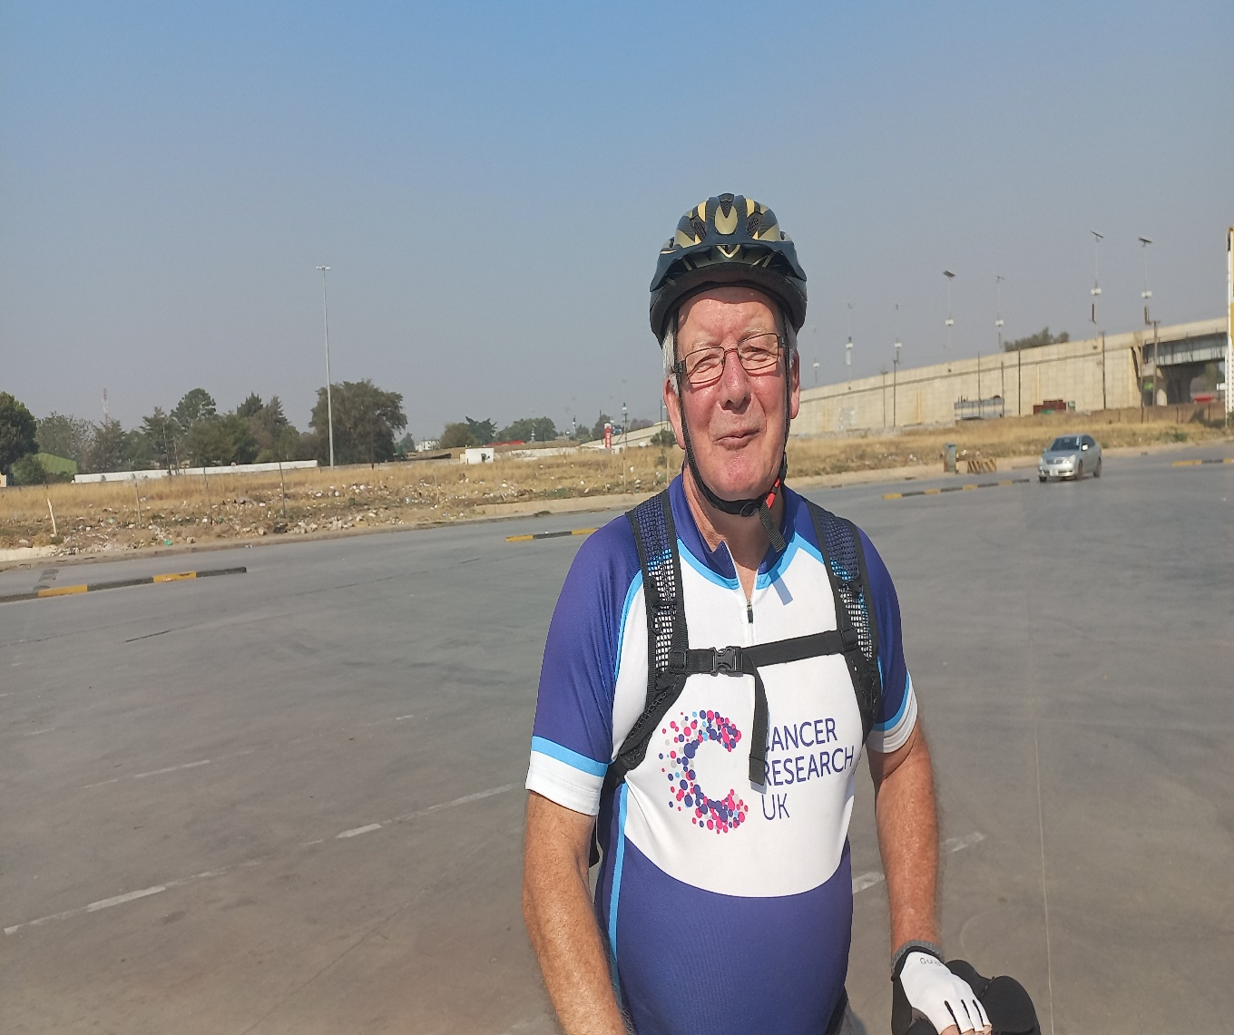This year, he set off with enthusiasm and determination, aiming to raise awareness and funds for this vital cause. His route was intended to lead him to the scenic destination of Victoria Falls in Zimbabwe, an adventure that garnered the support and admiration of many.

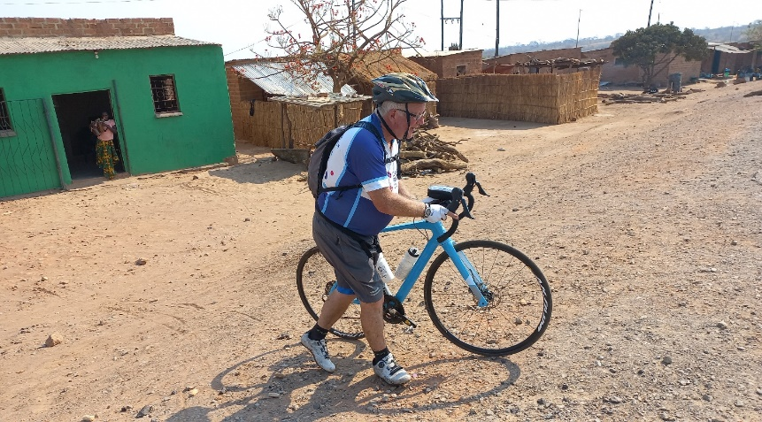

As he progressed towards Mazabuka, the team planned to check in into a lodge to ensure he had a comfortable place to rest after a long day of cycling.However,in a turn of events, we were unable to locate Roger upon our arrival in Mazabuka after checking in.We initially believed he might have continued his journey, given our early arrival.Unfortunately,we later received news that Roger faced a health issue that required immediate attention.

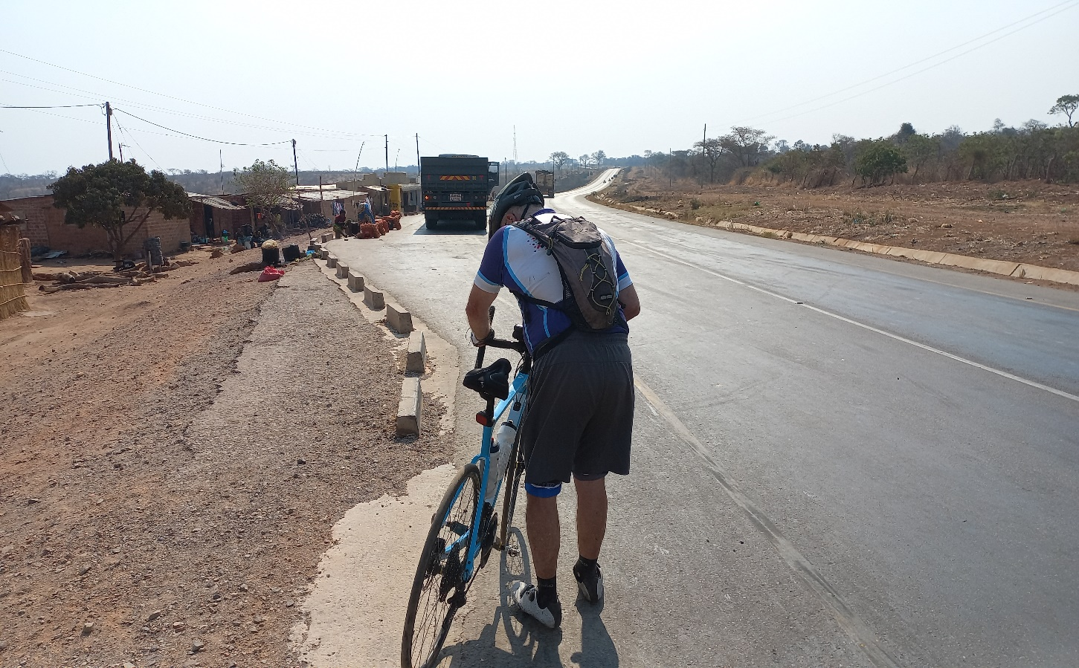

Thanks to the quick actions of a good Samaritan and others who came to his aid, Roger was transported to Victoria Hospital in Mazabuka for care. In light of the circumstances, we arranged for his transfer to Lusaka for further treatment, where he has been receiving the necessary support for the past two months.

Despite these challenges, Roger’s commitment to our mission remains steadfast. His journey symbolizes the heart and spirit of our organization, as we strive to create better living conditions for Zambian children in need of stable transitional housing. We are grateful to the Holycross sisters for the support during the difficult times. We look forward to creating a lasting impact on the lives of those we serve.Together,we can inspire change and provide hope for the future.

In addition to the accomplishments highlighted in this annual report, we are thrilled to share exciting developments from 2023/2024.last year, we purchased land that included a chalet, which will play a crucial role in our transitional housing for vulnerable children in Zambia.

While the transitional housing is not yet open, our dedicated team and volunteers have been working tirelessly on its rehabilitation. They have focused on cleaning,painting,and landscaping to prepare the chalet for its future use as a safe and nurturing environment.

We are also pleased to report that we have successfully drilled a borehole, and the installation of a tank, tank stand, and pump has been completed. These improvements will ensure essential water access for the children when the transitional housings open.

These ongoing efforts showcase our commitment to providing a safe and supportive environment for the children we aim to assist, and we look forward to welcoming them as soon the facility is ready.

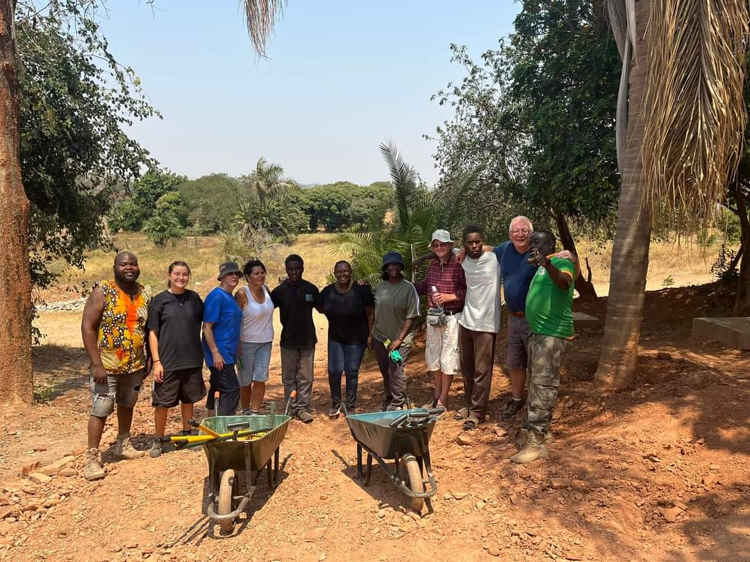

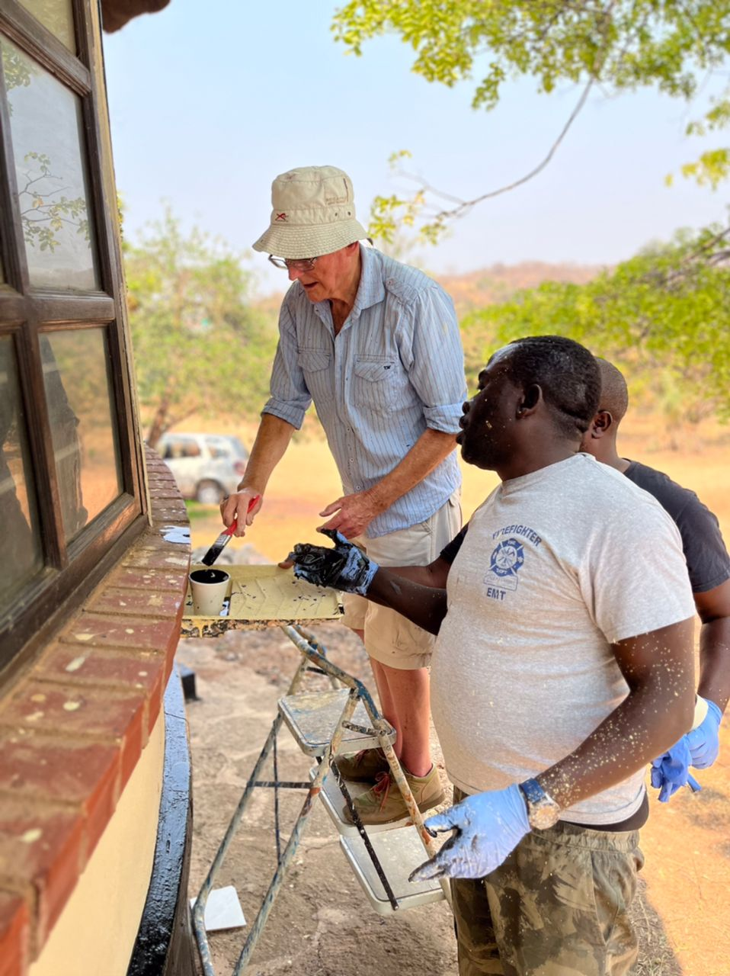

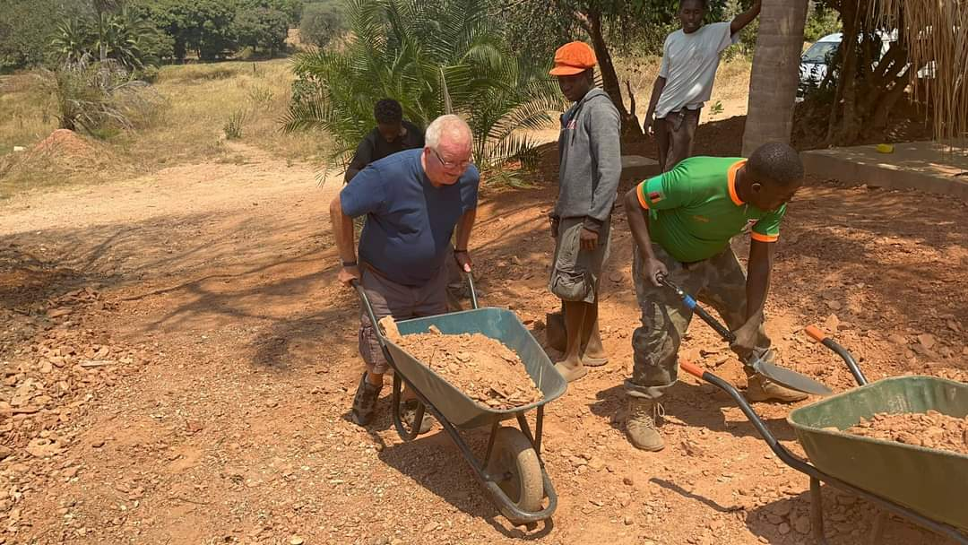

**5.Challenges Faced:**

As we reflect on the past year, it’s important to recognize the challenges that have hindered our progress and impacted our mission. Addressing these issues is critical as we strive for excellence and work towards our goals in the coming years. Here are some of the key challenges faced during 2023/2024:

* This year presented significant challenges that tested our resilience and adaptability. One major obstacle was the severe drought experienced in Zambia, which impacted not only the availability of resources but also the health and livelihoods of the communities we serve.Additionally,the frequent and prolonged load shedding presented severe logistical hurdles. With power available for only about three hours a day at certain times days without power. This lack of consistent electricity affected everything from basic communications to the ability to provide continuous information for our project.
* Family Situations: Some reintegration efforts were complicated by unfavorable home situations, necessitating additional support services for the children and their families.
* Stigmatization: Cultural stigma associated with children on the move(street children)sometimes led to community resistance against reintegration efforts.

**6.Strategies and interventions:**

In response to the challenges encountered during 2023/2024,we have devised a series of targeted strategies and interventions aimed at enhancing our operational effectiveness and achieving our goals.

* Comprehensive Team Development Programs: Implement training that focuses on building strong interpersonal relationships and collaborative skills within our team. This could include conflict resolution training and workshops on effective communication
* Peer Recognition Systems: Establish a peer recognition program to promote a supportive work environment. Encouraging team members to acknowledge each other’s contributions can strengthen bonds and improve morale.
* Conduct planning sessions at the beginning of each outreach initiative to set clear objectives, identify target audiences, and delineate roles and responsibilities within the outreach work.
* Impact Reporting: Develop a reporting system to assess the outcomes of outreach efforts regularly, highlighting successes and areas for improvement. Communicate these results to motivate and inform all stakeholders.
* Strengthened fundraising efforts through partnership, grants, and donor engagement to secure additional resources.
* Comprehensive Family Support: Developed programs targeting families who are unstable, offering counseling, and financial support to improve home environment for reintegrated children.
* Awareness Campaigns: Launched community awareness campaigns aimed at reducing stigma and encouraging community support for children on the move(street children).
* Developed a comprehensive case management approach to meet the specific needs of each child.
* Collaborated with local authorities and community organizations to promote inclusivity and social acceptance.
* Established a monitoring and evaluation system to track the progress and impact of our interventions.

**7.Collaboration and Partnerships:**

Footprints Partnered with several organizations to broaden our outreach and effectiveness.

Collaborations included:

* Eneless Patmos Community School
* Nsansa Village
* Vision of hope
* St. Lawrence
* Kasisi Orphanage
* Mthunzi
* Mother’s union St. peters Anglican church
* Fmdm sisters
* Holycross sisters

Together with the dedicated volunteers from African Freedom Mission and Mission Direct, these partnerships have enabled us to reach a greater number of children in need of care and support.

**8.Financial Summary:**

Our financial summary reflects a year of careful resource management and strategic investment. We remain committed to transparency and accountability, ensuring that the majority of funds are directed towards direct program services.

|  |  |  |  |  |  |  |  |  |  |
| --- | --- | --- | --- | --- | --- | --- | --- | --- | --- |
| Footprints Foundation for Children in Zambia Charity No 1151710 Annual Accounts Year End 31st March 2024  Income £29,010.31  Expenses £28,189.45  Closing Bank Account £10,544  31-3-2024 | | | | | | | | |  |
|  |  |  |  |  |  |  |  |  |  |
|  |  |  |  |  |  |  |  |  |  |
|  |  |  |  |  |  |  |  |  |  |
|  | |  |  |  |  |  |  |  |  |
|  | |  |  |  |  |  |  |  |  |
|  |  |  |  |  |  |  |  |  |  |
|  |  |  |  |  |  |  |  |  |  |
|  | |  |  |  |  |  |  |  |  |
|  |  |  |  |  |  |  |  |  |  |
|  | |  |  |  |  |  |  |  |  |
|  | |  |  |  |  |  |  |  |  |
|  | |  |  |  |  |  |  |  |  |
|  | |  |  |  |  |  |  |  |  |
|  |  |  |  |  |  |  |  |  |  |
|  | |  |  | |  |  |  |  |  |
|  | |  |  | |  |  |  |  |  |
|  |  |  |  |  |  |  |  |  |  |
|  |  |  |  |  |  |  |  |  |  |
|  |  |  |  |  |  |  |  |  |  |

**9.Future Plans and Recommendations**

Looking ahead, we plan to:

* Transit Home for Street Children: We plan to build transitional housing facilities specifically for children on the move(street children), providing them with a safe environment where they can receive care and support as they reintegrate into society. This initiative will initially focus on urban areas and may expand to other provinces in Zambia.
* Geographic Outreach: Develop strategies to reach more underserved children in various provinces, ensuring that our services are accessible to those in greatest need. By partnering with local organizations, we can identify areas with high populations to street children and tailor our approaches accordingly. Our strategic goals for the upcoming year focus on sustainability, enhancing program quality, and increasing community involvement.
* Funding and Resource Development:

Actively seek new funding opportunities to ensure sustainable growth and resources to support our initiatives.

* Our future strategies are guided by innovation,sustainability,and a deep commitment to our mission. We will continue to empower children, restoring their hope and potential, in collaboration with all our stakeholders.
* Community Awareness Campaigns in Community Schools:

Launch campaigns to raise awareness in community schools and the community on the issue of street children and the importance of providing support at community level, which can foster greater engagement and collaboration.

* Advocacy for Policy Change: Engage in advocacy efforts aimed at influencing national policies to better support the needs of street children.
* Staff Development: Recognizing the importance of a skilled and motivated workforce, the organization plans to invest in staff development programs. This will include training sessions, workshops, and seminars to enhance the knowledge and skills of the staff members

**Acknowledgments:**

We extend our deepest gratitude to our supporters,donors,and Volunteers for their unwavering belief in our mission.Together,we continue to make a lasting difference in the lives of children.

* **The Impact of Your Support**

We extend our heartfelt gratitude to you- our donors and sponsors-Who are the driving force behind our mission. Your generous financial support has been instrumental in transforming the lives of countless children.

This past year, your contributions have enabled us to reunite children with their families, offering them the safety and love they so desperately need. Your support has also provided vital medical attention for children living on the streets, ensuring they receive essential prescription medications to reclaim their health and well-being.

In moments of profound sorrow, your generosity has allowed us to honor the lives lost by purchasing caskets,blankets,bedsheets and clothing, granting them a dignified burial that reflects the respect and care they deserve.Furthermore,your assistance has facilitated crucial services such as providing shoes,haircuts,clothing,and showers for children transitioning back into their families, helping them start anew with dignity and hope.

Importantly, your contributions have empowered families of vulnerable children to start small businesses, enabling them to support and feed their children while remaining at home. This initiative not only fosters self-sufficiency but also creates a nurturing environment for the children to thrive.

Your commitment to our cause shines brightly in every life we impact. We are profoundly thankful for your belief in our mission and your willingness to stand alongside us in this important work.Together,we are making a powerful difference in the lives of the most Vulnerable.

Thank you for your unwavering support.

* **Volunteers**

We immensely grateful to all the dedicated volunteers who have selflessly devoted their time, skills, and energy to support children living on the streets. Your commitment, empathy, and mentoring have helped build a solid foundation for the personal and educational development of these children. Your effort has made a lasting impact on their lives**.**

Thank you for being part of the Footprints family.

**10.Conclusion**

As we conclude this year’s annual report, we reflect on a period marked by both significant challenges and remarkable achievements. The obstacles we faced, from the severe drought and frequent load shedding in Zambia to logistical disruptions, tested our resilience but also strengthened our resolve. Despite these trials, Footprints has continued to make a profound impact in the lives of children living on the streets.

The tireless dedication of our staff, the unwavering support of our partners, and the generosity of our donors have been instrumental in enabling us to overcome adversity and achieve meaningful progress.

**Bless Our Children. Guide their elders. Guard their interests. Keep them safe.**